***Deez Nuts*A Meme Token With Benefits  
  
  
White Paper  
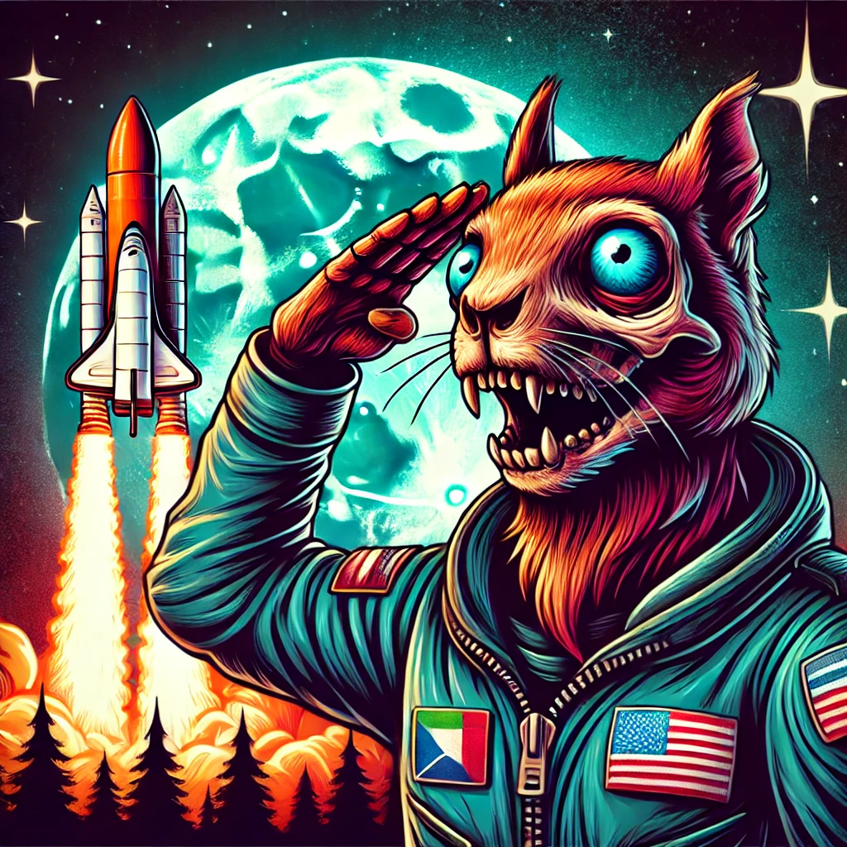  
Deez (NUTS) Meme Token  
Deez Nuts (NUTS) is a meme-inspired cryptocurrency launched on the Algorand blockchain. Combining humour, pop culture, and advanced blockchain technology, Deez Nuts aims to offer a fun and rewarding experience.**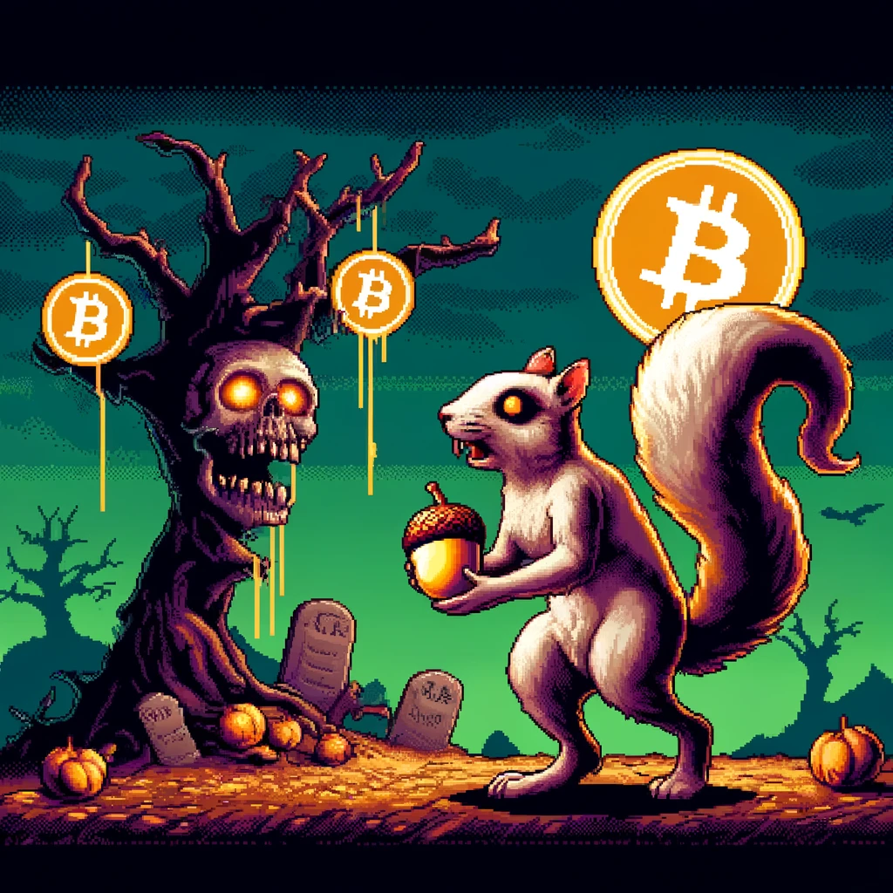

* **Total Supply**: 69,696,969 NUTS  
  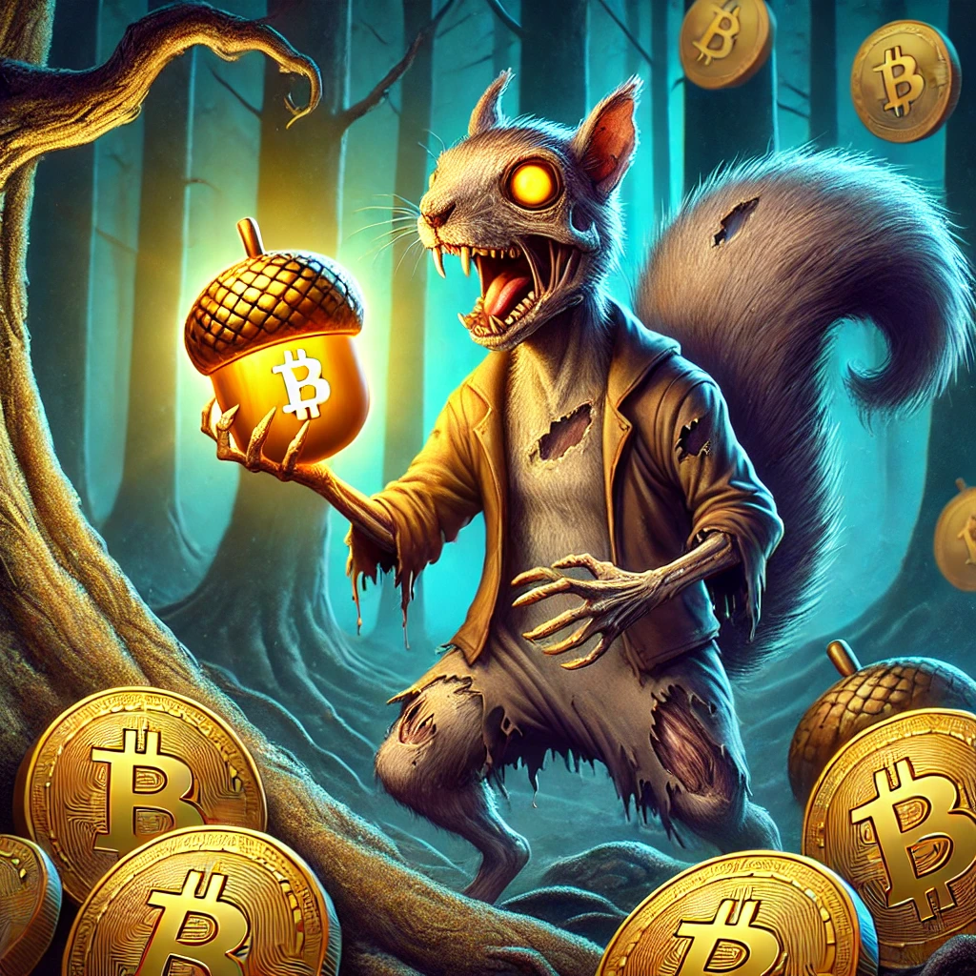
* **Distribution**: Fair launch supported by Rug Ninja, with tokens locked via Vestige Vaults.

### **Features**

**Staking and Rewards:**

* **Cometa Staking Pools: Stake NUTS to earn goBTC rewards, known as drizzle rewards.**
* **Periodic Buybacks: The Genesis wallet buys NUTS to support the market on Rug Ninja, ensuring healthy buyback to acquire reward distribution pools and burn pools.**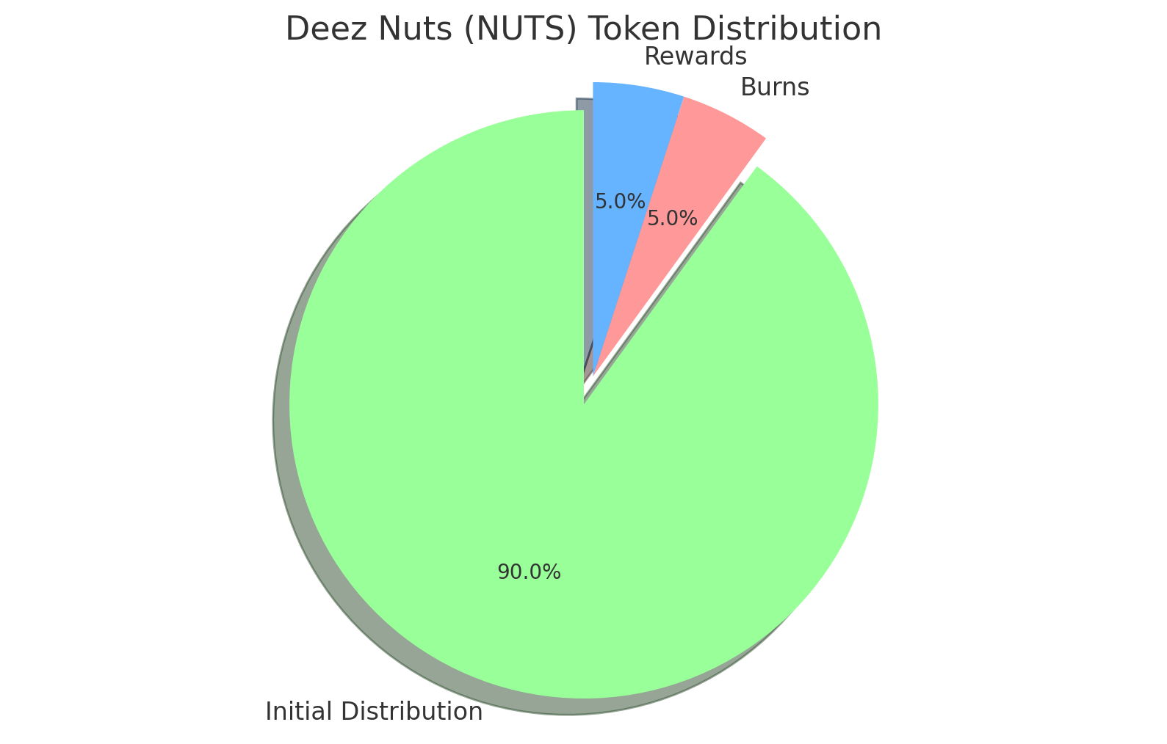

**Genesis Wallet Strategy:**

* **10% Allocation: Split into 5% for rewards and 5% for burn.**
  + **5% for Rewards: Funds staking rewards (Sold for Algo to buy GoBTC for drizzling.**
  + **5% for Burn: Offsets market supply selling from the GoBTC drizzle purchase.**

### **10% bought off the floor is a donation from Mr. Peanut to kick-start the rewards pool and build community bonding with burns.**

### 

### **Roadmap**

* **Q3 2024: Stealth launch like a Ninja, exchange listings TinyMan (Dex), community building, verify with pera.**
* **Q4 2024: Launch of staking pools, token burn event, expanded community engagement.**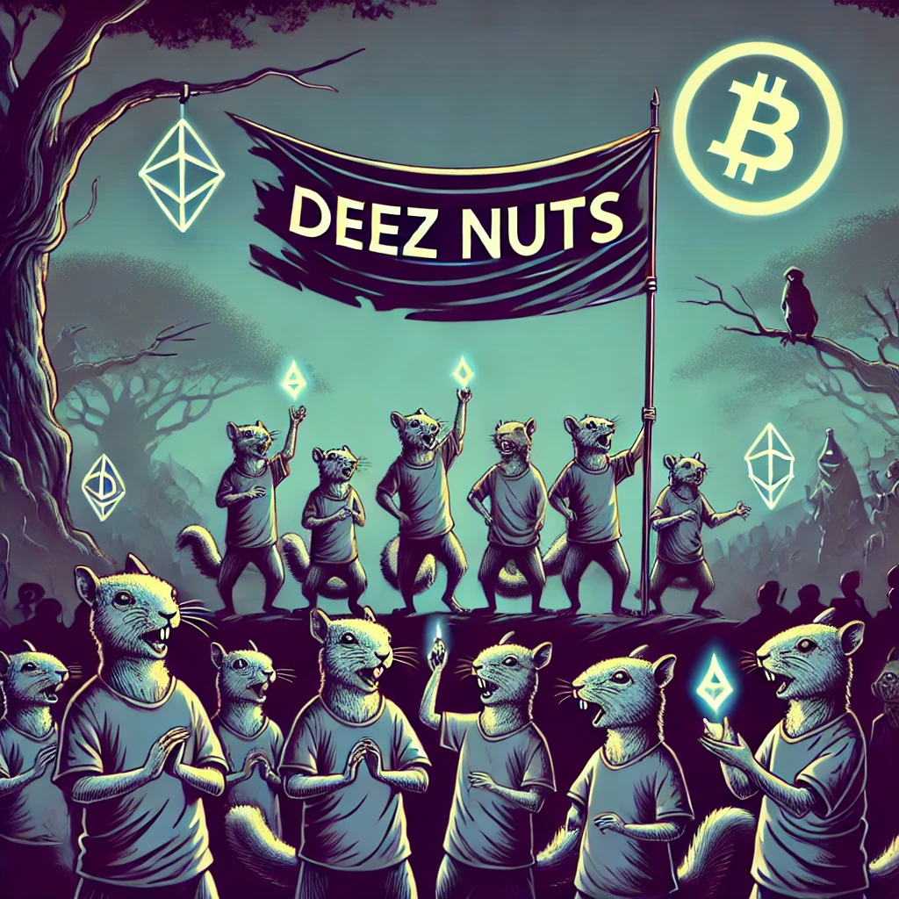

### **Community Engagement**

**Minimal Official Presence:**

* **Twitter: Deez Nuts**

**@DeezNuts0i0  
  
Always check the @ to make sure Zero-i-Zero is present.  
Will never ask for a Seed phrase or any wallet info**

* **Community-driven growth and organic engagement.**

### **Importance of Minimal Social Presence for Deez Nuts**

#### **Unified Communication**

### **Centred Information: By maintaining a single official presence on X (Twitter), the entire community has one place to access all updates and information. This ensures everyone is equally informed without needing to hunt down details across multiple platforms.**

#### **Community Growth**

### **Organic Development: As the community grows, members can initiate their own Discord and Telegram groups. If Deez Nuts supports these initiatives, they can be officially recognised and listed as community mediums, maintaining an organised and authentic network.**

#### **Fair Access to Information**

### **Preventing Confusion: Limiting official channels reduces the risk of misinformation and scams. Too many media outlets can lead to confusion and exploitation by fake sites or profiles, especially as the project gains momentum.**

#### **Security and Trust**

### **Authenticity: Mr. Peanut will never DM or reach out directly to individuals. This policy helps to prevent phishing attacks and scams. Trust only the official X (Twitter) account for Deez Nuts for accurate and safe information. Conclusion**

**Deez Nuts is more than a meme token; it's a community-driven project blending humour with real value. Join us on this journey to make an impact in the crypto world.**